Website Topic_____________CLICK&FIX_______________________

Student name:_____________Robertas Aleksandrovas_______________________

Student number:_______S00224661____________________________

Date:____________________25/04/22________________________

Github website link : https://sunlesssapphire.github.io/webdesignproj/

Checklist done

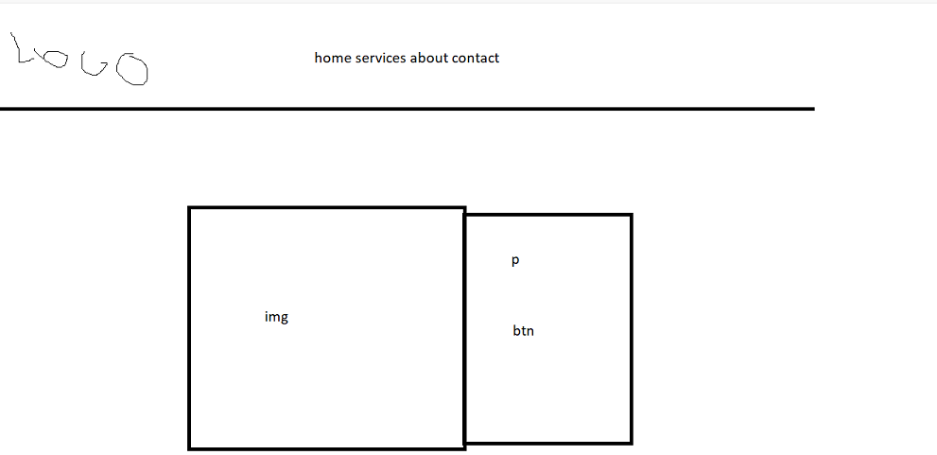index page. Main page of the website you can see the button you can choose at the top which one you want to choose and the button in the middle goes to services images were borrowed from the internet using google

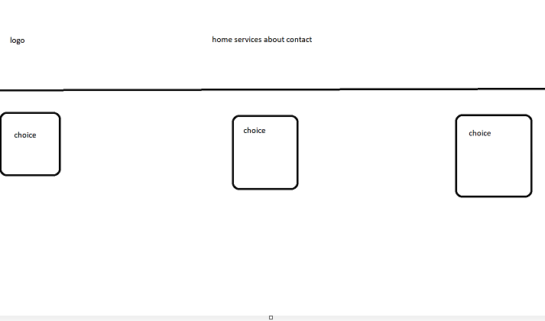
Services page. Gives you 3 choices between what you want to choose with the same navigation bar from the main page, this goes on.
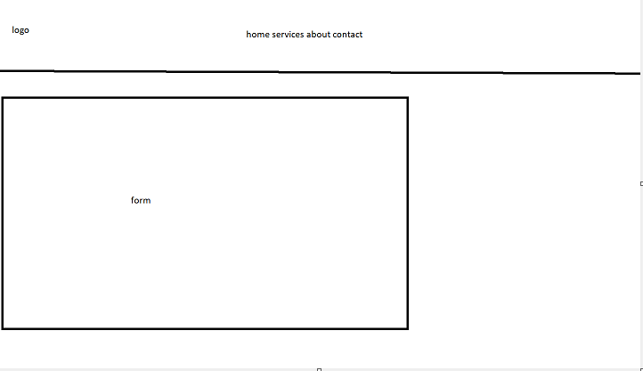
Same layout for page 3 and 4 after choosing the a service and choosing contact page.

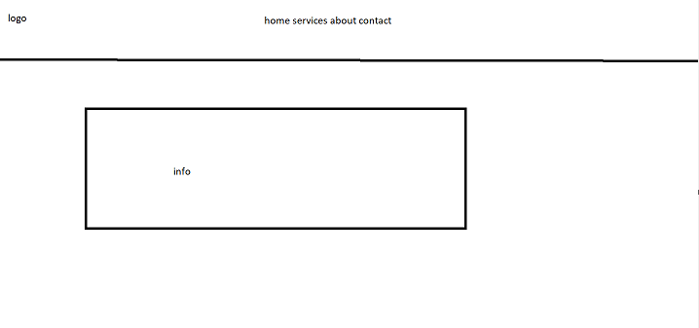
About us page explaining what this website does in the simplest way.

